How to download your department’s inventory from Canopy:

1. Log into [Canopy](https://canopy.tamus.edu/Login.aspx?ReturnUrl=%2fModules%2fFFX%2fAssetSearch.aspx)

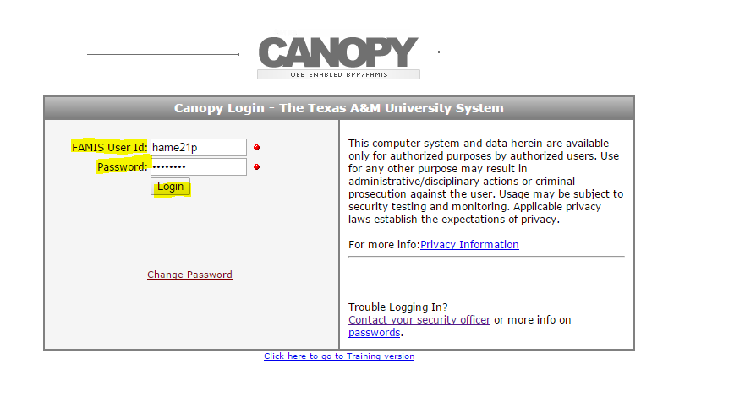

1. Click on FFX in either of the two locations

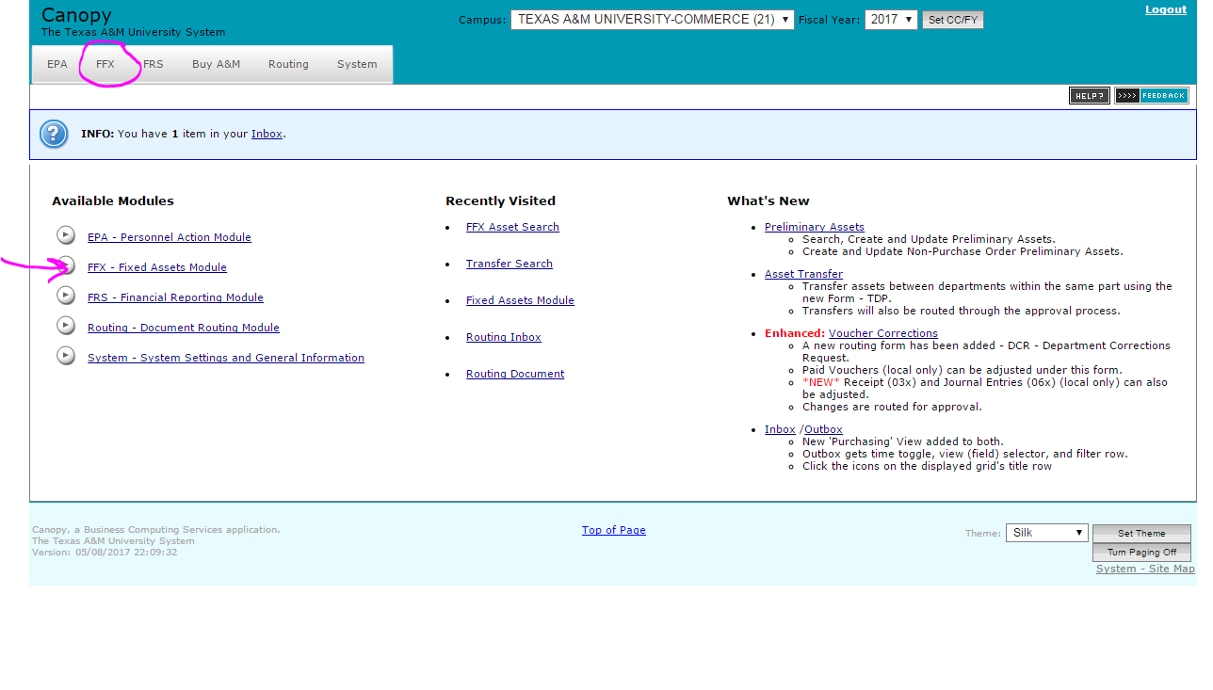

1. Click on Search

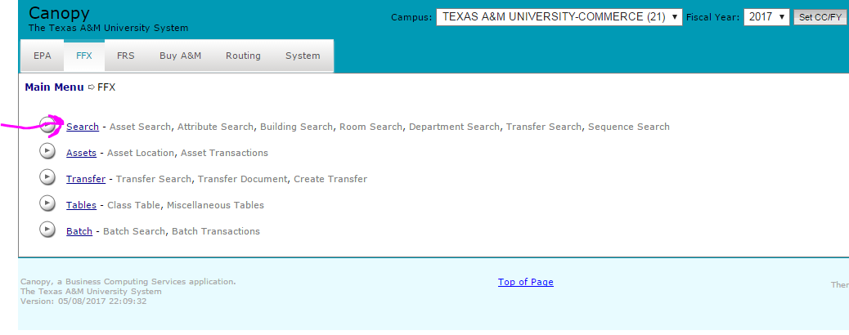

1. Type in your department code and click search (example: for Financial Services, our department code is ‘FISC’) it is not case sensitive.

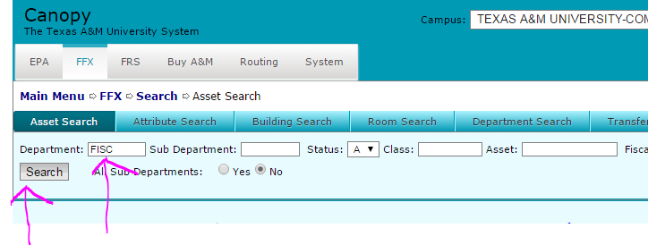

This will generate a listing of your inventory, like below…… make sure to note there could be multiple pages.

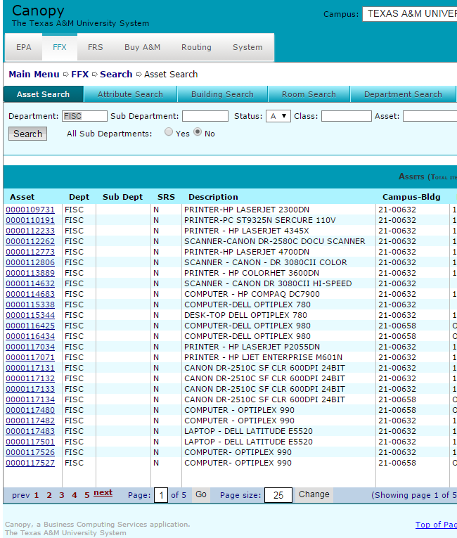

1. 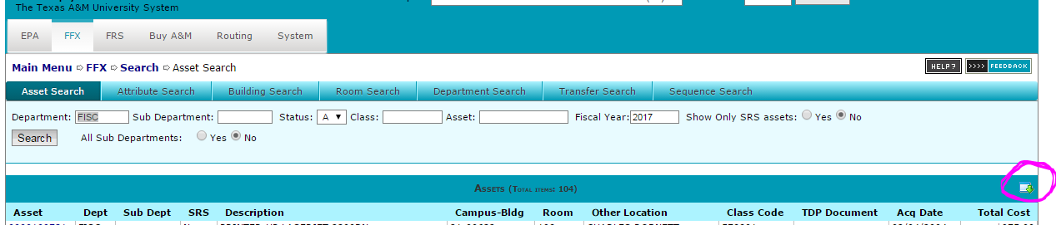To generate this information in an excel document click the download button at the far right hand side of the screen above the ‘total cost’ column.



This will bring up your entire inventory into an excel spreadsheet. It will give you way more information than you actually need, so you can go through and delete what you are not looking for.

FYIs:

* You can see any department’s inventory on campus but can only transfer the assets associated with your department code.
* The information that pulls into the ‘room number’ column and the ‘other location’ column are only as kept up to date as the person responsible for updating them keeps them. If the ALT APO does not keep those fields updated through Canopy or FAMIS, the same information will stay there forever.
* If CITE or Summus takes one of your computers for the replenishment project, you as the department’s Alternate Accountable Property Officer (Alt APO) are supposed to immediately transfer it from your inventory to PLANT SURP.
* If you find an asset that doesn’t belong to your department, follow the below path to see who’s inventory it falls under:
  + Log into Canopy🡪click on FFX🡪click on ‘Assets’🡪type in the asset number of the item (ex:0000xxxxxx)it will always have 4 zeros in front of a 6 digit number🡪click submit🡪all of the information pops up on that asset(screen shot below). Circled in pink is where you will find whose inventory it belongs to.
  + 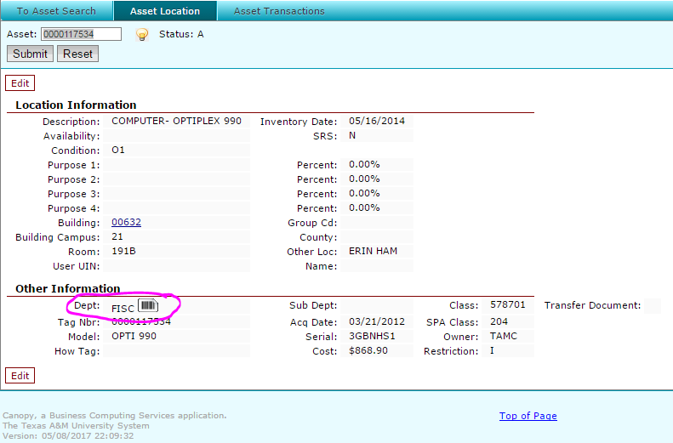
  + If you do find an asset that belongs to someone else, please contact the ALT APO for that department to see if they need the asset back. If you are unsure of who to contact, please call the Property Manager for clarification.

|  |
| --- |
| **Debbie Gonzalez** |
| *Grant Accountant & Property Manager* |
| Financial Services  |  McDowell Administration, BA191G |
| P: 903.886.5482 |
|  |
| *Mail:* P.O. Box 3011, Commerce, TX 75429 |
|  |
| [TAMUC logo](https://www.tamuc.edu/) |